Asbury Payer Mix - PCC

Presented to: | ThriveWell Tech / Jon Morrison, Jason Hershey
Version Number: | Draft V2
Revised Date: | 19-05-2025

Table of Contents
1 Overview 3
1.1 Project Overview 3
1.2 Asbury Communities 3
2 Project Requirements 3
3 Data Sources 4
4 ETL Process Design 4
4.1 Extraction 4
4.2 Trasformation 4
4.3 Loading 4
5 Data Mapping 4
6 Workflow and Scheduling 4
7 Error Handling and Logging 4
8 Testing and Validation 4
9 Documentation and Reporting 5
10 Maintenance and Support 5
11 Appendices 5
12 Technical Details 5
13 Qlik Reporting Sheets 5
14 UAT Cases 5
15 Changes from MyUnity 5
Version Change Control 6

1 Overview

A Payer Mix Report is a financial analysis report that breaks down the revenue sources of a Health Care provider based on the types of Insurance Payers. It helps Hospitals, Clinics, and Health Care Organizations understand how their revenue is distributed across different payer categories. Data is systematically processed through AWS Glue and Redshift, then visualized in a Qlik application for better decision-making.

1.1 Project Overview
Overview
Project Name | Asbury Payer Mix - PCC
Project Description | The report provides a detailed insight of Payers and census status for all Asbury communities those gone live on PCC beginning Feb’24 onwards.  Refer to Section 1.2 for Asbury Communities
Project Start Date | November 2024
Stake Holders | Jon Morrison, Jason Hershey
Additional Notes (Add as required)

1.2 Asbury Communities
Below listed are the Communities the Payer Mix report is prepared for.
IL - Independent Living
AL – Assisted Living
SNF - Skilled Nursing Facility
Communities | Level of Care
Asbury Solomons | IL, AL, SNF
Asbury Methodist Village | IL, AL, SNF
Bethany Village | IL, AL, SNF
Springhill | IL, AL, SNF
Riverwoods | IL, AL, SNF
Normandie Ridge | IL, AL, SNF
Asbury Grace Park | IL, AL
Asbury Ivy Gables | IL, AL
Chandler Estate | IL, AL

2 Project Requirements
This section provides the detailed Business and Technical Requirements to deliver this project.

Business Requirements:
- Provide accurate payer distribution data for Independent Living (IL), Assisted Living (AL), and Skilled Nursing Facility (SNF).
- Monitor trends in census days and payer contribution over time.
- Track Budget vs. Actual occupancy data across communities.
- Generate KPIs like Occupancy Rate, Payer Mix %, and Average Daily Census for strategic insights.
- Integrate data from multiple sources (PCC, UltiPro, GP, NetSuite) into a unified view.
- Ensure security and access controls to protect sensitive healthcare data.

Technical Requirements:
The technical environment and tools required to support the successful implementation of the Payer Mix Report include:
Infrastructure:
- Cloud Provider: AWS
- Database: Amazon Redshift (Data Warehouse)
- Storage: AWS S3 (Raw and processed data)
- ETL Orchestration: AWS Glue
- Data Migration: AWS DMS
- ODBC Connector: NetSuite ODBC Driver for data extraction
Software:
- BI Tool: Qlik Sense
- Data Sources Integration: APIs/Connectors for:
  - Point Click Care (PCC)
  - Ultipro
  - Great Plains (GP)
  - Netsuite
  - Kronos
  - PbjLog
  - Budget Static Files (CSV, Excel)
Processing:
- ETL Framework: Custom Glue Jobs using PySpark/Scala
- Data Format: Parquet, JSON, CSV (as applicable)
- Transformation Patterns:
  - Slowly Changing Dimensions (SCD)
  - HUDI transformations for incremental data load
  - Standardization and data cleansing logic
Scheduling:
- Scheduler: AWS Glue Triggers & CloudWatch Events
- Job Timings: Twice daily (2:00 AM and 11:00 AM EST for extraction and transformation).
- For more details on job scheduling refer to Section 6.
Security & Access:
- IAM Roles for access control to Glue, S3, Redshift
- Audit Logs for ETL activity tracking
- Secure FTP for file-based data inputs
Performance Considerations:
- Optimized Redshift table designs using sort keys and distribution styles
- Monitoring via CloudWatch Metrics for ETL jobs and Redshift usage

3 Data Sources
Below listed are the data sources for this project.
- Data Sources (including type) - Point Click Care (PCC), Ultipro, Greatplains, Netsuite, Budget static file
- Format - Raw/source data
- Location – AWS S3

4 ETL Process Design

4.1 Extraction
- Source Systems: Source systems used for this report are Point Click Care (PCC), Ultipro, GP, Netsuite.
- Data Extraction Methods: AWS DMS, Netsuite ODBC Driver

4.2 Transformation
- Data Cleaning: AWS Glue used for data validation, cleansing, and standardization.
- Data Transformation Rules: Used SCD and HUDI transformations on the data in AWS Glue.

4.3 Loading
- Target Systems: AWS Redshift
- Loading Methods: AWS Glue used for loading data.

5 Data Mapping
- Source to Target Mapping: Manual mapping of source data fields to target data fields.
- Jobs
- Data mapping

6 Workflow and Scheduling
- ETL Workflow: Visual representation of the ETL process flow.
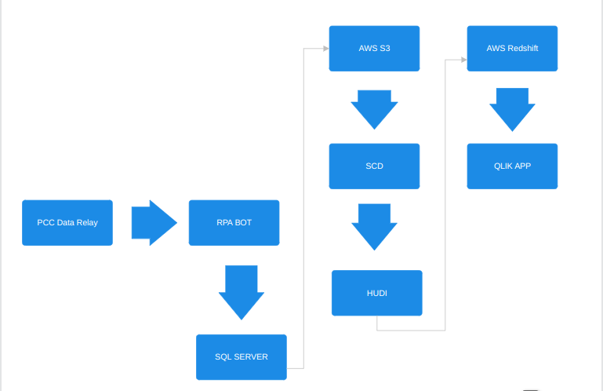
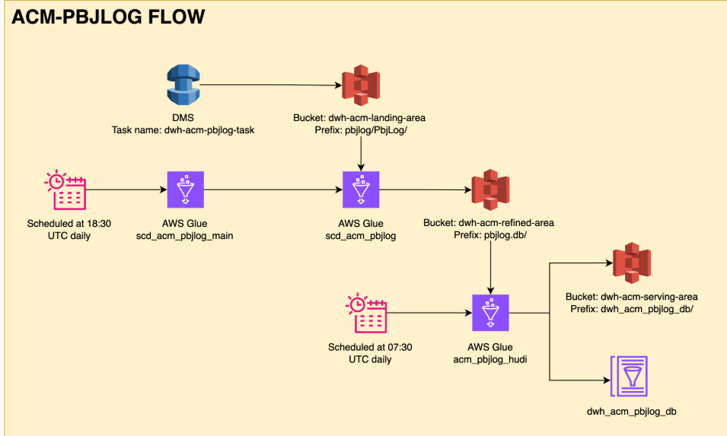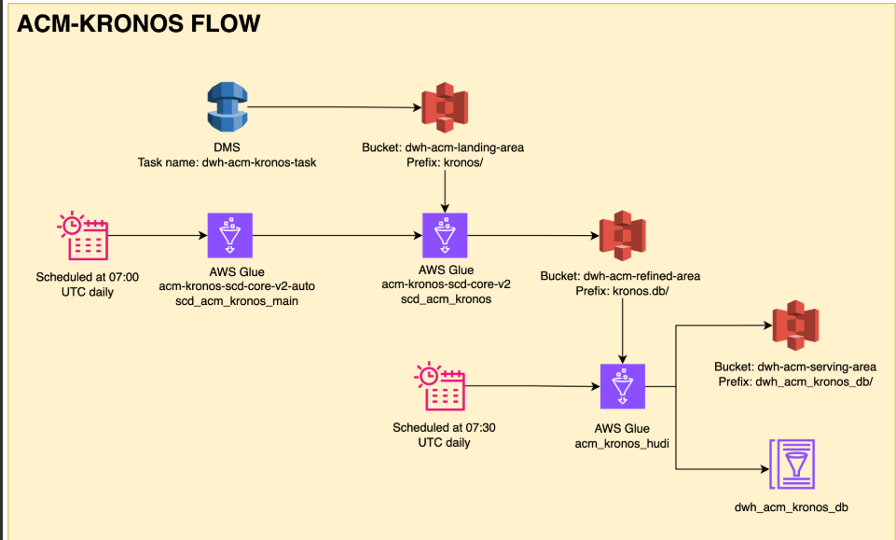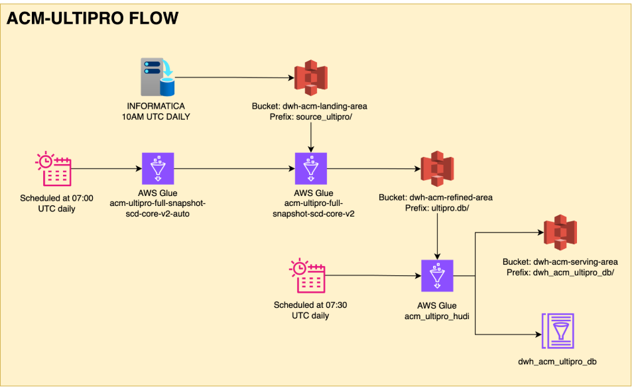
- Job Scheduling: Details on job scheduling, including frequency and dependencies.
(All timings in EST)
- Data for the backup file pulled at 0 hour (3:00 AM and 10 AM)
- 15 In FTP
- 30 Bot
- 31 File Time backup file
- 40 SQL Server loads backup file
- 00 AWS source data extraction and transformation. 55 minutes duration (scheduled at 2:00 AM and 11:00 AM)
- load Qlik (5 minutes) (scheduled at 5:45 and 11:45 AM)
- 12 PM run reports

7 Error Handling and Logging
- Error Handling Procedures: Steps to handle errors during the ETL process.
- Logging Mechanisms: Methods for logging ETL activities and errors.

8 Testing and Validation
- Test Plan: Detailed plan for testing the ETL process.
- Test Cases: Specific test cases and expected outcomes.
- Validation Procedures: Methods for validating data accuracy and completeness.

9 Documentation and Reporting
- Documentation: Comprehensive documentation of the ETL process, including code and configuration files.
- Reporting: Methods for generating and distributing reports on ETL performance and issues.

10 Maintenance and Support
Maintenance Plan
- To ensure the continued accuracy, reliability, and performance of the Payer Mix Report, the Data Engineering and Analytics teams are responsible for the following ongoing maintenance activities:
- ETL Job Monitoring:
  - Regularly monitor AWS Glue job executions via CloudWatch.
  - Review logs for job failures, delays, or data quality issues.
- Redshift Performance Tuning:
  - Monitor table sizes, query performance, and vacuum operations.
  - Perform regular optimizations, including updating statistics, sort keys, and distribution styles.
- Data Quality Checks:
  - Implement automated validation rules (e.g., row count checks, null checks).
  - Schedule periodic audits to ensure data integrity.
- Security Reviews:
  - Review IAM roles and access permissions quarterly.
  - Monitor and log unauthorized access attempts.
- Data Source Connectivity:
  - Maintain and update ODBC drivers, APIs, and DMS connectors as needed.
  - Test integration endpoints and credentials regularly to avoid failures.
- System Upgrades:
  - Stay current with AWS Glue, Redshift, and Qlik updates and patches.
  - Validate report compatibility after upgrades or new feature releases.
- Backup File Management:
  - Ensure timely ingestion of backup files from FTP locations.
  - Validate backup file structure and content before processing.
Support Procedures
- The support team will follow a structured escalation and resolution procedure to handle production issues efficiently:
- Issue Identification:
  - Detected through automated alerts (AWS CloudWatch), manual user reports, or scheduled audits.
- Logging and Tracking:
  - All issues logged in the internal ticketing system (e.g., Jira, ServiceNow) with timestamps, severity levels, and assigned owners.
- Resolution Timeline:
  - Critical issues (e.g., ETL failure, Redshift down, Qlik not loading): Resolved within 2–4 hours.
  - Medium issues (e.g., delayed reports, data mismatch): Resolved within 1 business day.
  - Low-priority issues (e.g., enhancements, formatting requests): Resolved within 3–5 business days.
- Communication Protocol:
  - Immediate stakeholders (Jon Morrison, Jason Hershey) are notified in case of any production delays or critical issues.
  - Resolution summaries are shared via email or Teams after ticket closure.
- Knowledge Base:
  - Maintain and update SOPs (Standard Operating Procedures) for frequent issues and recurring support tasks.
  - Documentation is stored in a shared Confluence or SharePoint location accessible by the support team.
- Post-Incident Review:
  - A root cause analysis (RCA) is performed for high-severity issues.
  - Lessons learned and preventive measures are documented and shared with the team.

11 Appendices

11.1 Glossary:
Term / Acronym | Definition
Payer Mix | The distribution of a healthcare provider's revenue by type of payer (e.g., Medicare, Medicaid, Private Pay, Insurance).
PCC (PointClickCare) | A cloud-based EHR platform used by senior care providers for clinical and financial data management.
ETL (Extract, Transform, Load) | A data integration process for extracting data from sources, transforming it, and loading it into a target system.
HUDI | Hadoop Upserts Deletes and Incrementals – used for incremental data processing and versioning.
SCD (Slowly Changing Dimension) | A data warehousing concept used to manage and track changes in dimension tables over time.
AWS Glue | A serverless data integration service for discovering, preparing, and combining data.
Redshift | Amazon's cloud-based data warehouse solution for large-scale data storage and analytics.
Qlik Sense | A Business Intelligence tool used for creating interactive reports and dashboards.
Census Days | The total number of days a resident is present in a facility during a specified period.
Occupancy Rate | The ratio of occupied beds to total beds in a facility.
IAM (Identity and Access Management) | AWS service used to manage access to AWS services and resources securely.
CloudWatch | AWS monitoring and observability service for cloud resources and applications.
DMS (Database Migration Service) | AWS service for migrating databases from on-premises to AWS cloud.
FTP (File Transfer Protocol) | A standard network protocol is used to transfer files from one host to another.

11.2 References:
Resource | Description
PointClickCare Documentation | Official reference for APIs, data structures, and integration methods with PCC.
AWS Glue and Redshift Documentation | AWS technical resources for Glue job development and Redshift configuration.
Qlik Sense Developer Hub | Documentation and community forum for Qlik scripting, visualization, and reporting.
Asbury Community Guidelines | Internal documentation outlining reporting needs and community structure.
Healthcare Data Compliance Guidelines | HIPAA and other relevant data governance requirements.
Internal Data Dictionaries and Mapping Sheets | Source-to-target mappings, data definitions, and ETL transformation logic maintained by the data team.

12 Technical Details
The technical details include:
Tables, Procedures and Views:
Tables | Procedures | Views
Date table | dim.load_datetable(); | Vwbed
Entity | dim.load_entity(); | Vwcensus
Facility | dim.load_facility(); | Vwbuilding
Campus | dim.load_campus(); | Vwbedoccupancy
Campus active dates | dim.load_campusactivedates(); | Vwbedoccupancy2ndperson
Level-of-care | dim.load_levelofcare(); | Vwdate
Building | dim.load_building(); | Vwdischarges
Unit | dim.load_unit(); | Vwpayer
Room | dim.load_room();
Bed | dim.load_bed();
Resident | dim.load_resident();
Admission action | dim.load_admissionaction ();
Admission status | dim.load_admissionstatus ();
Admission | dim.load_admission();
Payer | dim.load_payer();
Payer plan | dim.load_payerplan();
Budget Plan Days | dim.load_budgetplandays();
Bed occupied | dim.load_bedoccupied();
Bedavailable | dim.load_bedavailable(); dim.update_bedavailable();
BedOccupancy | dim.load_bedoccupancy();
Census | dim.load_census();

13 Qlik Reporting Sheets
Please find attached spreadsheets for the Qlik reporting sheets.
Below is the link to the reporting tool
Payer_Mix_Qlik_Report

14 UAT Cases
Test Case ID | Description | Input Data | Expected Output | Result Criteria
UAT_01 | Validate data ingestion from PCC | Sample data from PCC | Data correctly ingested into S3 | Data rows match source record count
UAT_02 | Verify SCD logic for payer records | Existing + new payer entries | Existing records updated, new ones inserted | SCD Type 2 history maintained
UAT_03 | Confirm data transformation rules | Raw vs. processed data | Transformed fields as per rules | Validated using Glue logs
UAT_04 | Ensure successful load to Redshift | Transformed data files | Data appears in Redshift staging and fact tables | Row count and schema validation
UAT_05 | Validate Qlik dashboards | Loaded Redshift data | Accurate visuals and KPIs | All Qlik visuals populate correctly
UAT_06 | Test job scheduling and timing | Trigger time | Jobs execute as scheduled | Confirmed in AWS Glue and CloudWatch
UAT_07 | Error handling verification | Simulated data error | Logs capture error and notify | Errors logged and retried or flagged
UAT_08 | Backup file load process | Uploaded backup | Data available for reporting | Successfully processed and visualized
UAT_09 | Security access control | IAM Role access | Only authorized users access data | Access logs and permission test

15 KPI
Payer Mix KPI's (Includes Daily Occupancy KPI’s), additional KPI’s are listed below.

KPI Name | Description | Formula/Logic
Payer Mix % | Percentage of census days by payer type | (Payer Census Days / Total Census Days) * 100
Total Census Days | Number of days resident was present in facility | Sum of census days for each resident
Revenue by Payer | Total billed revenue by each payer category | Sum of billed amount grouped by payer
Average Daily Census | Average number of residents per day | Total Census Days / Number of Days in Period
Occupancy Rate | Percentage of occupied beds | (Occupied Beds / Total Beds) * 100
Payer Trend Over Time | Trend of payer mix by month | Time series based on Payer Mix % monthly
Budget vs Actual Days | Comparison of budgeted and actual census days | Actual Census Days - Budgeted Days
Resident Count by Payer | Number of unique residents by payer type | Count distinct residents grouped by payer
Facility-wise Payer - Distribution | Payer mix distribution per facility | Group by community and payer mix

16 Reported Issues
1. A custom mapping rule was implemented to classify all payer plans with names starting with 'Benevolent' under a consolidated payer category labeled 'Benevolent.' This adjustment aligns with business requirements to standardize payer representation for analytical consistency in the payer mix reporting..

Version Change Control
Version | Change | Date  (Mo-Day-Year) | Updated  By
Draft V1 | Created draft version of Payer Mix Report | 25-03-2025 | Vaishnavi.Lakhera
Draft V1 | Updated community details, Qlik Screenshots, Overview | 27-03-2025 | Vaishnavi Lakhera
Draft V1 | Updated Qlik report snapshots and its link and data sources | 01-04-2025 | Vaishnavi Lakhera
Draft V1 | Updated points highlighted in the mail: 4,5,6,7,10 | 08-04-2025 | Siddharth Mittal
Draft V2 | Updated Jobs and data mapping details | 25-04-2025 | Vaishnavi Lakhera
Draft V2 | Updated data workflow | 30-04-2025 | Vaishnavi Lakhera

